WEGROW DESIGN LLC: INTERIOR DESIGN BUSINESS PLAN
Institution Affiliation
Student’s Name
Date of Submission

INTERIOR DESIGN BUSINESS PLAN
WEGROW DESIGN LLC
Hello since you already released the payment only way I can receive the bonus is by posting a new homework or emailing me at amazingmuimi96@gmail.com. I’m ready to fix anything if need be.
Business Summary
Wegrow is an interior Building and design Company owned by Naomi Chavful and Kris Daves. Wegrow designs are located in (11906) Rosmarino Ct Richmond TX, 77406, and registered as a Limited Liability company. It is a new interior design company that offers interior design services both for a commercial and residential buildings in the Rosmarino area. It also offers full design services that are affordable, including personalized services. Additionally, Wegrow interior design delivers access to other products such as lighting, furniture, designing arts, as well as fabrics and accessories.
The owners (Naomi Chavful and Kris Daves) have qualities of managing the company. They have a degree certificate in interior design school in the United States. Naomi has an MBA from America's school of Economics. She has more experience in managing the business as well as experience in working with an interior design company in New York. Kris Daves has worked for over ten years with one of the best interior design companies in Europe before moving to America. He unites with Naomi to come up with a Wegrow building and interior design Company. The owners are registered interior designers under the law in New York. As owners and managers of the Wegrow Interior design Company, they can manage it daily, including all that fall under professional contact. However, the other areas of services offered include; consultations on matters of interior decorations both on commercial and residential.
Mission and Vision Statement
The vision of Wegrow Interior Design is to come up with a standard interior design firm that will be able to provide services not only in the Rosmarino area but also in the larger US and the rest of the world. The mission is to have a company that will provide quality interior designs and projects and emerges as the best choice for the majority and real estate agencies.
Market Research
All business collect their business information in many ways such as data collection through surveys, websites, work experience, friends through innovation and creativity, customers, articles, and books that help them on how to plan, operate and evaluate their activities to reach the desired goals and objectives. Additionally, projected government statistics and the company's insiders can also provide ideas about business. However, for the case of the Wegrow Interior design Company, the owners came up with information about the company after making friends with each other. Naomi met his friend Kris Daves who had facts about the company. From his working experience in Europe, he was able to advise, encourage, and support Naomi, who had the interest of having the same business in the future.
As qualifiers in the field of Interior design, they amalgamated and came up with a detailed analysis of the business as they combine their knowledge, skill, experience, and effort to come up with such a company. That was the primary source of the business idea, but the owners continued taking more research about the company from the operations of the other existing companies. Rosmarino area is growing at a higher rate in terms of the general population and developments. More investors are getting into the area. They come up with new companies, organizations, and institutions that require interior design. As a result of few existing related companies in the area, Wegrow Interior Designers was created to provide products and services by competing with other firms as well as offering enough services to meet the demand of their potential clients available in the area.
The sources known that provide a competitive environment with Wegrow Interior Designers are from other interior design companies around the area. Another form of competition is the “DIY” where people use their resources to design for themselves. Sometimes, retail stores and other websites provide the resources to the people. For instance, there are big stores like Wal-Mart, Target, and Home goods that offer design accessories at a discount rate by selling facilities like beddings, furniture, and other home and office items. Additionally, websites like the overstock and way fair sell interior design accessories. Such sites commit to promoting how it is easy and fast to access the products just by clicking the button. For instance, there has been an increased demand for interior design products and services in the sector of building and remodeling in the Rosmarino area. Statistics have shown that for the last year, both residential and commercial interior design firms spawned millions of dollars in sales in the greater Rosmarino area coverage. Following the increasing trend from the previous years, next year's projects an increase of more than 30 percent in the sales of products and services. The industrial and local trends that will affect the success of the company include; changes in designs such as styles, and the use of fabric colors will pose a significant challenge to reach the desired ends. The effect from the national discount stores like the Wal-Mat and Home Depot, which provides extensive products and services at a cheap cost, can reduce customers' preference.
Marketing plan
The projections show that the Rosmorino areas' economy is growing at a higher rate, and more people are coming up with new homes and buildings. Then, they explore interior design in improving both their residential and commercial buildings. The marketing plan for Wegrow Interior Design Company will be based on dividing the market into three parts. The first portion is on new home construction. Wegrow Interior Designers will go for these projects. This will be achieved through making consultations and request with contractors by preparing master plans, floor design as well as strategic planning of the building. Secondly, remodeling of the projects, and in this case, Wegrow Interior Designers can take control of the project or work as consultants with contractors. Thirdly, they will focus on the interior design of the existing homes.
All the three parts have covered the more substantial portion of the building process addressed to interior designers and which will help Wegrow Interior Designers to win the market available. The company will provide varieties of products and services from its operations to satisfy the needs of its customers in the Rosmarino area as well as across the world. They will offer the following; on-site consultations, analysis and project surveys, furniture arrangement and space planning, furnishing and finishing, designing customs and concepts, purchasing, delivery, and installations, as well as management and project coordination. They will use boards that contain pictures of their services and products. For example, in the picture below, they have illustrated how they can help with space planning, purchasing, delivery, and installation of office equipment.

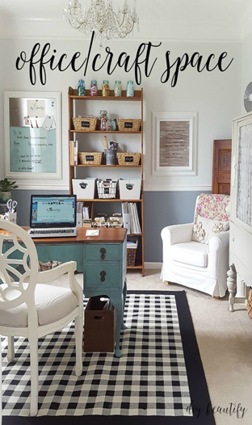
Services and products will be priced based on the value offered to the client while comparing others in the same market. The general prices will be determined by the best design services and quality products offered. Because it is a starting firm, Wegrow Interior Designers will not provide warehouse services for the meantime. Still, in the long run, they will come up with service delivery and warehousing services.
The advertising and promotion activities that will boost the business will be based on the following potential sources. However, the promotion strategy will focus on how to generate referrals links to expose it to more people. One of the promotion sources will be the Newspapers advertisements where adverts will be selected in the Boulder Herald. Adverts on TVs and specifically, Martha Stewart and Interior motives displayed on local TV shows. Lastly, postcards, where a direct mail postcard will be delivered to the clients' mail list. Most of the businesses have peak and off-peak seasons. For the case of interior design companies, most of the sales are believed to increase from the third month to the eighth month of the year. This is clearly shown in the graph below.
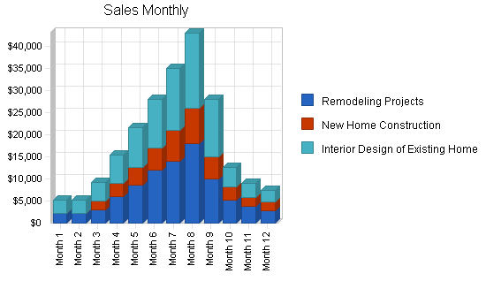
https://www.bplans.com/home_interior_design_business_plan/images/bf5ea451fa92449a959a9a9af29e3612.png
Operational Plan
The organizational structure of Wegrow Interior Design will comprise of the following personnel, the Chief Executive Officer (Kris Daves) and the creative director (Naomi Chavful), as the topmost positions. The others include HR and administration manager, sales and marketing executive, accountants, interior designers, and the client service executive. The hiring will be based on an individual level of education, where one must have a bachelor's degree in the field of Interior design and must be proficient in the following; AutoCAD, Adobe Suite, Microsoft Office Suite, and Sketch Up. Other ethical aspects are one must be responsible, well organized, good timekeeper, and have a strong work ethic. All of them will be selected concerning their academic qualifications as well as job experience.
All the records will be kept by the accountants, who will also prepare financial reports, statements, and the company's budget. All these will be done through written information like balance sheet projects and financial statements and presented to the board of management. Initial, there will be no more benefits to the employees, but when the company enjoys economies of scale as a result of expansion, employees'' salary is likely to be increased. Those who perform well in their respective departments will get promoted to high ranks as per their efforts. The company will have terms and conditions. Once the suppliers, subcontractors and delivery people agree to the terms and conditions of the company, there will be no complexities that will arise between them and the company, therefore, creating a conducive working environment.
Financial Information
The table below provides the projection of Wegrow Interior Design's initial capital and how it will be spent.
Products/Services | Amount ($)
Business Incorporation Fess | 750
Liabilities; insurance, permits, and license | 3,500
Renting of Office and Store space | 150,000
Equipment: computers, printers, projectors, markers, servers/internet facility, furniture, telephones, filing cabinets, and electronics. | 10,000
Purchases of Software Applications | 500
Launching of the official Website | 500
Bills and employees’ salaries (3 months) | 70,000
Other expenditure: Business cards, Signage, Adverts, and Promotions | 5,000

By considering the information collected from the market research and the feasibility studies carried out, Wegrow Interior Design will require at least four hundred thousand (400,000) US dollars to come up with a standard Interior design company in America.
The graph below projects the Wegrow Interior Design break-even analysis. The monthly break-even point is approximated at $14,800.
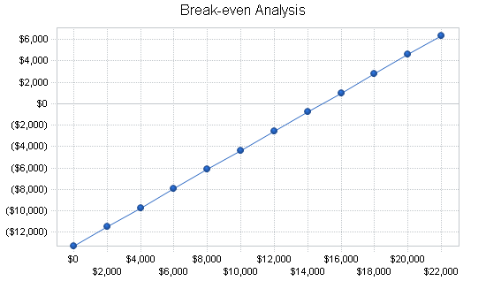
https://www.bplans.com/home_interior_design_business_plan/images/ac2813bb8a0b4dfd9ae40a96aeedc6ee.png
The table below shows the monthly revenue beyond the break-even points.
BREAK-EVEN ANALYSIS | AMOUNT ($)
Monthly Revenue Break-Even | 14,800
Assumptions;
Average Percent Variable Cost | 11%
Estimated Monthly Fixed Cost | 13,300

Month-by-month projected Profit and Loss Statements.
Wegrow Interior Designers projected profit and loss is shown on the graphs below for monthly;
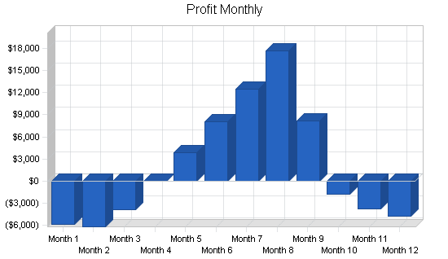
https://www.bplans.com/home_interior_design_business_plan/images/c9c022773a9d4ae7b3fd1cc35243c3dd.png

Wegrow Interior Designers project that it is likely for them to experience losses in the first three months of the year. Then, peak off starts from the fourth month to the ninth month. For the last three months of the year, they will face a reduction in sales that will cause them to experience losses.
Wegrow Interior Designers beginning balance sheet
Wegrow Interior Designers,
Beginning balance sheet,
Assets ($) | Liabilities ($)
Cash 100,000 | Current Liabilities
Accounts Receivable (Net) | Accounts Payable
Prepaid Expenses 100,000 | Other
Total Current Assets 200,000 | Total Current liabilities
Fixed Assets
Equipment 10,000 | Total Liabilities 250,000
Leasehold 190,000 | Stakeholders Equity 150,000
Total Fixed Assets 200,000 | Paid in Capital
Total Assets 400,000 | Total Liabilities and Net worth 400,000

SWOT Analysis
Wegrow Interior Design will make use of business professionals who major in the areas of consultants and structure to help the company in building an active interior design business that can compete favorably. The consultancy team will cooperate with the management to research on SWOT analysis to identify the areas of strength and weakness of Wegrow Interior design Company.
Strengths
The workforce is one of the most substantial areas where Wegrow Company will have a team of highly qualified interior designers. The team will also have significant experience in interior design. Secondly, the existing good relationship between the stakeholders and the company. This will help then to get support from their stakeholders when they need it.
Weaknesses
The greatest weakness is that Wegrow Interior Design is a starting company; in Houston, Texas, it will take a long time for the company to start dominating the market and be accepted by the top clients and government in the existing industry. Another weakness is that the company can lack enough capital to operate its business effectively and efficiently.
Opportunities
Wegrow will provide the best quality products and services at a lower cost than others in the market. The qualified team of designers will provide new and unique facilities from other companies to give a facelift of the company. Also, they are ready to take any opportunity arising in the industry.
Threats
An economic downturn is one of the significant threat anticipated by Wegrow Interior Design. Economic slump interferes with the sales and production activities of the company. Another significant risk is the development of the same Interior design company in the same location. This will affect the target market of the company and can reduce its sales, thus low profit.

References
Ajaero T. Martins, (2009, n.d). Profitable Venture Magazine Ltd. Article about: Writing an Interior Design Business Plan. Retrieved from: https://www.profitableventure.com/interior-design-business-plan/
Gibbs, J. (2005). Interior design. Laurence King Publishing.
Knackstedt, M. V. (2012). The Interior Design Business Handbook: A Complete Guide to Profitability. John Wiley & Sons.
Phillips, N. (2009). How to Start a Home-based Interior Design Business. Rowman & Littlefield.
Pinson, L. (2008). Anatomy of a Business Plan: A Step-by-step Guide to Building the Business and Securing Your Company's Future. Aka associates.
Rayfield, J. K. (1997). The office interior design guide: an introduction for facility and design professionals. John Wiley & Sons.

